# FORTICLIENT SSL VPN FOR WINDOWS

Step 1: Download software from https://www.forticlient.com/downloads

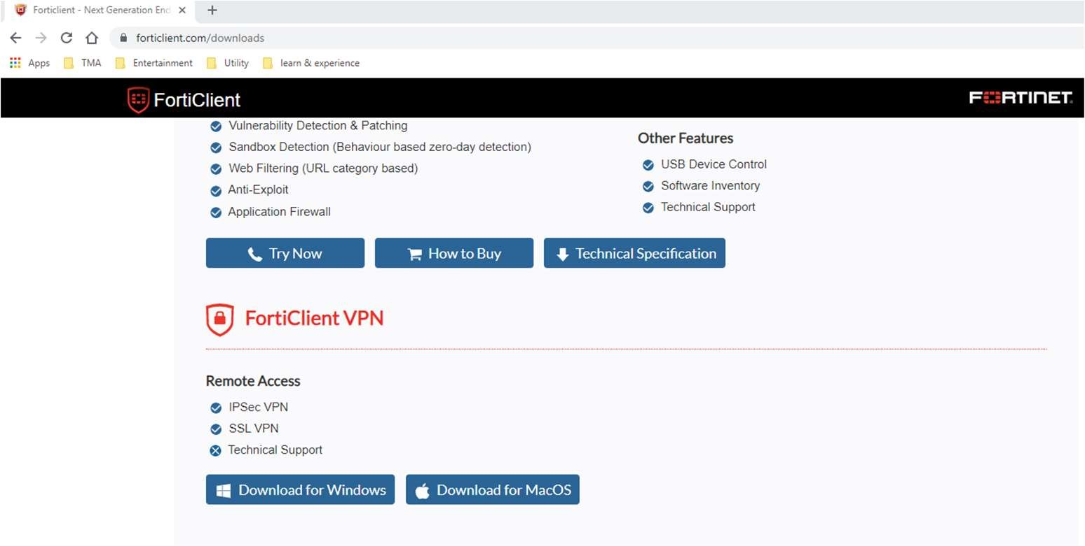

Step 2: Open FORTICLIENT VPN → Click “add a new connection“

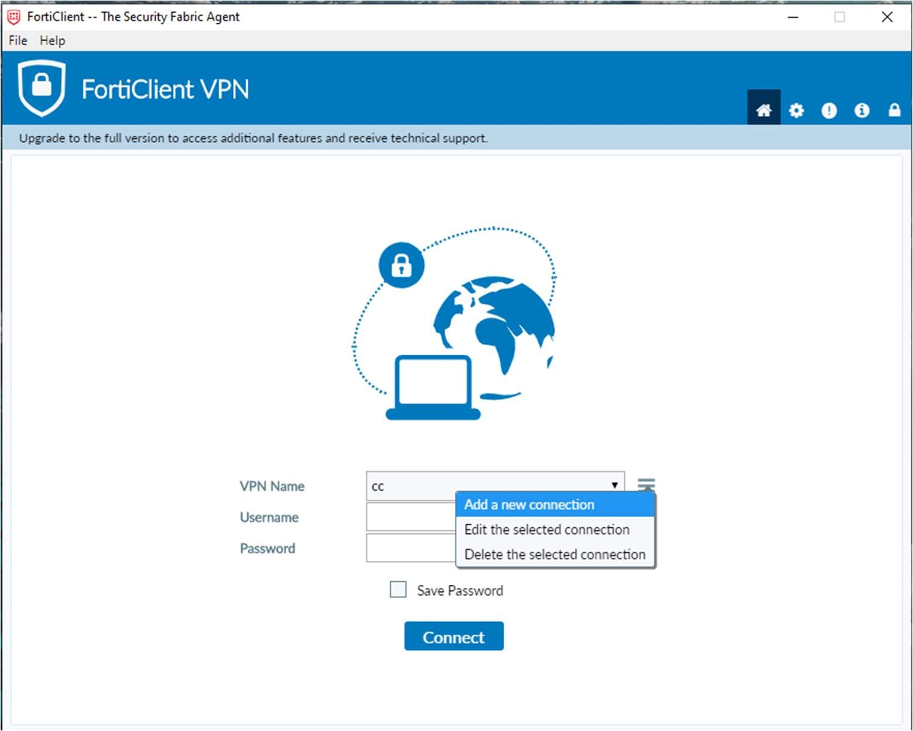

Step 3: Fill info as picture below. Remote gateway follow your site

Ex: pn-wah.tma.com.vn

qtsc-wah.tma.com.vn

tip-wah.tma.com.vn

Step 4: Accept Certificate and fill your Account - Password

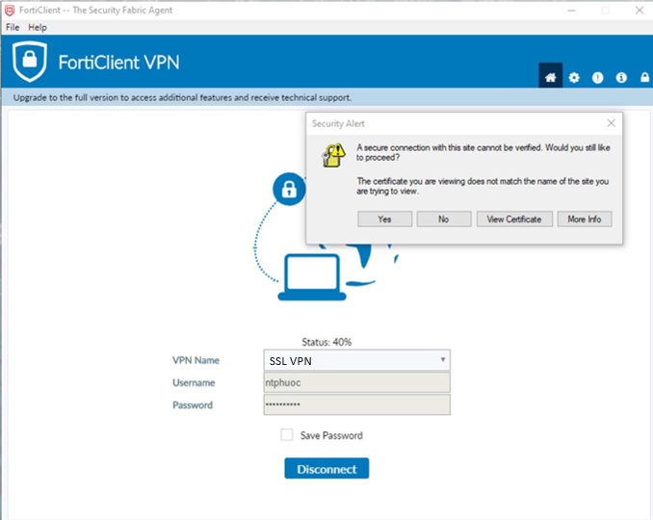

Now you can use your Remote desktop or VNC applications to access your PC working

# FORTICLIENT SSL VPN FOR MAC OS

Step 1: Download software from https://www.forticlient.com/downloads

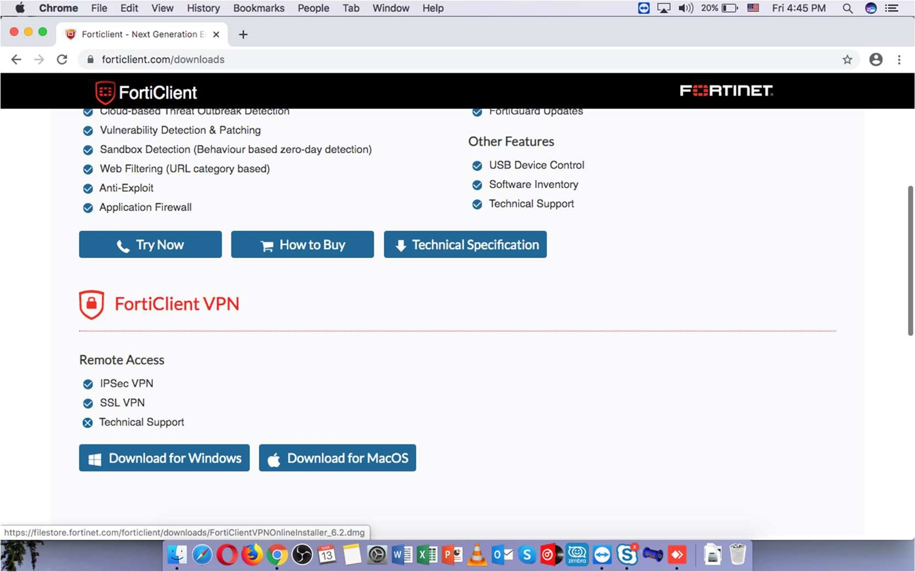

Step 2: Open FORTICLIENT VPN → Click “add a new connection“

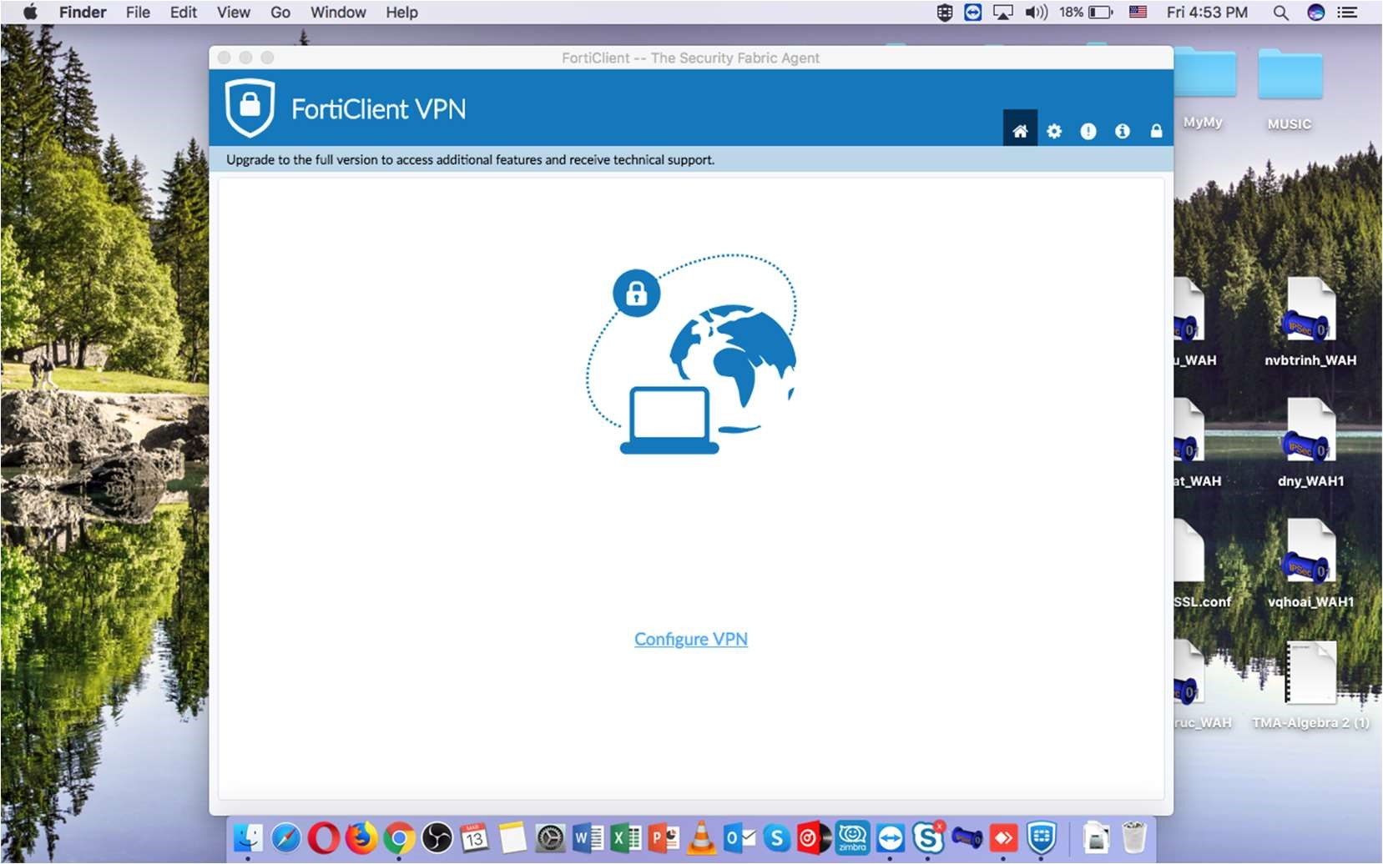

Step 3: Fill info as picture below. Remote gateway follow your site

Ex: pn-wah.tma.com.vn

qtsc-wah.tma.com.vn

tip-wah.tma.com.vn

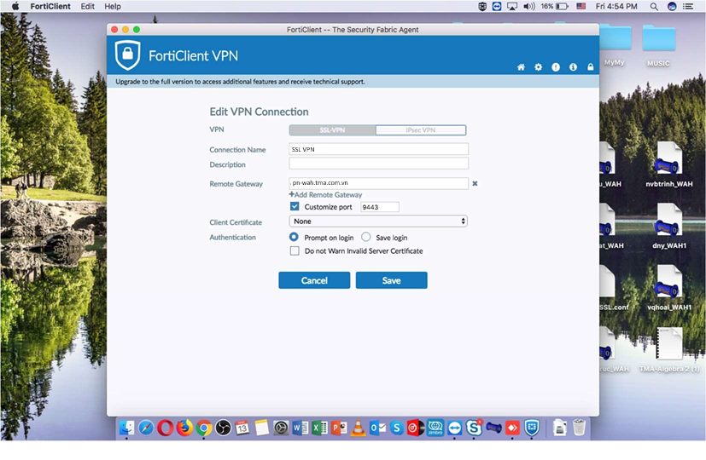

Step 4: Accept Certificate and fill your Account – Password

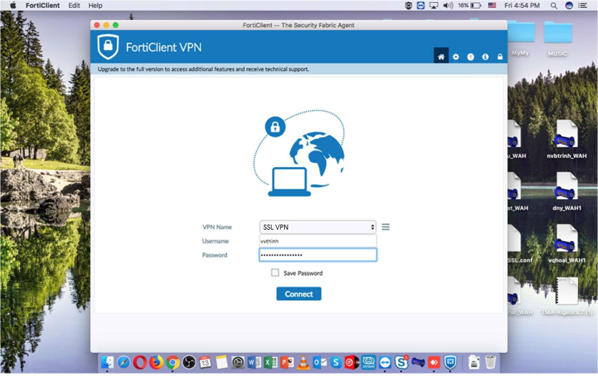

Now you can use your Remote desktop or VNC applications to access your PC working